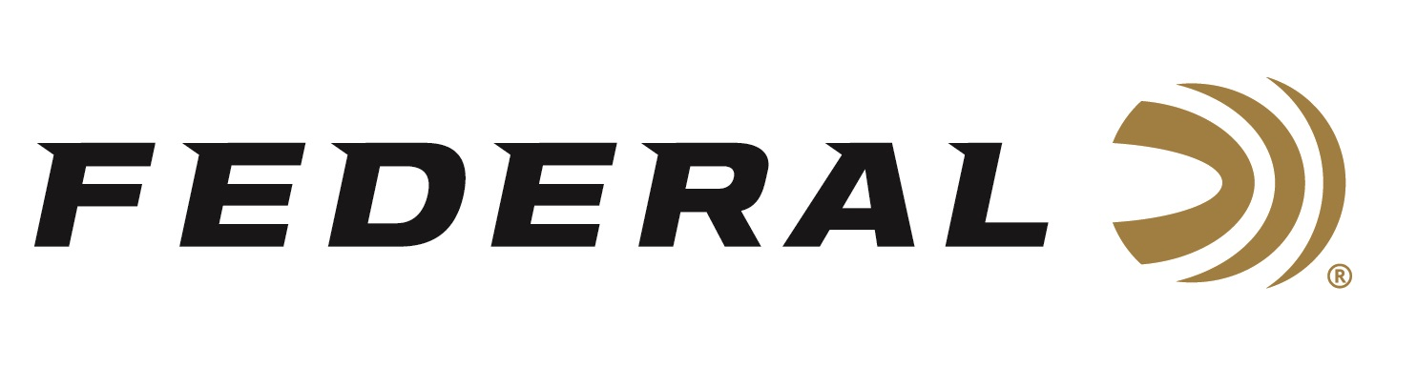

FOR IMMEDIATE RELEASE

Mallard Mania on This Episode of the “It’s Federal Season” Podcast

ANOKA, Minnesota – October 8, 2020 – If you are a passionate waterfowler or just getting started, this episode of “It’s Federal Season” is a must listen. Chad Belding, host of the top-rated waterfowl television show “The Fowl Life” on Outdoor Channel, chimes in with tips and tactics on how to be successful in the field this season.

Episode No. 13 - Mallard Mania
https://www.federalpremium.com/podcast.html

“Chad is so passionate, and his knowledge is undeniable,” said Federal Ammunition’s Vice President of Marketing Jason Nash. “He is a diehard waterfowler and his advice is backed with decades of hunting experience from all the major flyways from east to west coast,” said Nash. Belding delivers a ton of waterfowl information during this high energy episode including proper concealment, essential gear to get started, shot size preference for ducks and geese and how to get a new hunter involved and into the duck blind.

In the Tech Talk segment, Belding, sponsored by Federal Ammunition, talks about the importance of the Black Cloud ammunition from Federal found exclusively in his blind bag. “I remember the very first time I went on a spring snow goose hunt with Black Cloud,” said Belding, the veteran waterfowl hunter. “There were no cripples and the dogs had an easy job that day,” continued Belding. Since that day, there is no other choice for Belding and his Benelli shotguns based on patterning, pattern consistency and lethality of the system that combines the FLITECONTROL FLEX wad and the pellet combination of Premium Steel and FLITESTOPPER Steel.

Before signing off, find out what promotions are available for consumers to buy Federal products and merchandise. Look for more podcasts at www.federalpremium.com or where you find your favorite podcasts.

Federal ammunition can be found at dealers nationwide or purchased online direct from Federal. For more information on all products from Federal or to shop online, visit www.federalpremium.com.

Press Release Contact: JJ Reich
Senior Manager – Press Relations
E-mail: VistaPressroom@VistaOutdoor.com
About Federal Ammunition
Federal, headquartered in Anoka, MN, is a brand of Vista Outdoor Inc., an outdoor sports and recreation company. From humble beginnings nestled among the lakes and woods of Minnesota, Federal Ammunition has evolved into one of the world's largest producers of sporting ammunition. Beginning in 1922, founding president, Charles L. Horn, paved the way for our success. Today, Federal carries on Horn's vision for quality products and service with the next generation of outdoorsmen and women. We maintain our position as experts in the science of ammunition production. Every day we manufacture products to enhance our customers' shooting experience while partnering with the conservation organizations that protect and support our outdoor heritage. We offer thousands of options in our Federal Premium and Federal® lines-it's what makes us the most complete ammunition company in the business and provides our customers with a choice no matter their pursuit.

